Take Home Exam 08: Nernst Potential

## Assigned: 10/26/2022

Due (as pdf by email) 10/30/2022 (Sunday)

HW 09

09.1

Make a map* of the OCV (the Open Circuit Voltage) or the Nernst potential using the equation derived in class, today, using the activity at the anode and at the cathode as the y and the x axis in your map. The activities range from nearly 0 to 1 (unity) - the value of zero would make the chemical potential go to minus infinity, so beware.

(i) Remember that the  , always*).* Therefore the map would be viable only in the upper (diagonal) half of the map.

(ii) Remember also that the Nernst voltage will be zero along the diagonal across the map drawn from (0,0) to (1,1).

Briefly give the reason for (i) and (ii).

*The map should show contours of battery voltage (for example contours for 0.5 V, 1 V, 2 V, 3V)

09.2

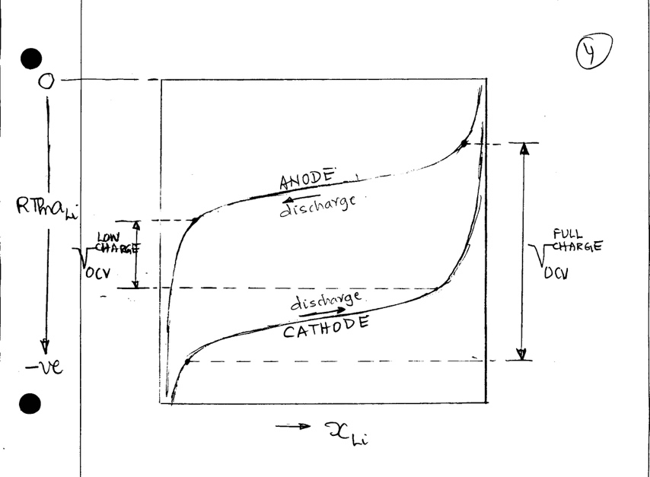In the diagram on the right,  is the molar concentration of Li in the anode/cathode. The activity is related to  as following



where  is called the activity coefficient. This equation applies to both the anode and the cathode by writing the parameters with subscript or superscript

, etc.

(i) Draw the graph again for the case where the activity coefficient is equal to unity. The show how the voltage will vary as the battery is gradually discharged.

(ii) Draw a conceptual profile for the activity coefficient as the molar concentration increases from near zero upto to unity, for both the anode and the cathode, relative to one another in one graph.